
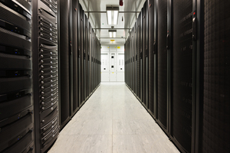
9th April 2014

18:00 for 18:30

University of Aberdeen, Room F61 Edward Wright Building, Dunbar Street, Aberdeen,
AB24 3QY

ABERDEEN BRANCH

Visit to University of Aberdeen Data Centre

Eighteen months ago the University of Aberdeen, Robert Gordon University, Aberdeen College, and Banff & Buchan College agreed to pool resources and jointly invest in one state-of-the-art shared data centre.
Following the ten-month project, the new data centre, based at the King’s College campus of the University of Aberdeen, now hosts the IT infrastructure for the four institutions. The project has reduced the sector’s carbon footprint by more than 1,400 tonnes annually, as well as slashing energy bills by more than a quarter of a million pounds each year.
The project involved re-locating all 400 servers in the previous University of Aberdeen’s data centre and hundreds from the other partner institutions, re-locating and re-wiring over 100 live network components and two full Janet racks, replacing all flooring and ceilings and major external construction work.
The visit will give an opportunity to hear more about the centre and the network and to tour the facility.

Everyone is welcome. Refreshments provided. Admission is free.
Information:
http://www.abdn.ac.uk/maps/old-aberdeen-details-2526.php

