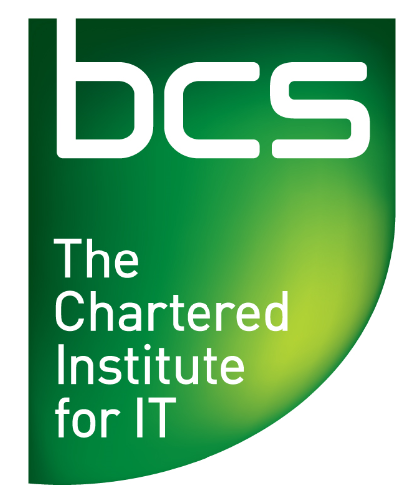
Delivering Heterogeneous
Computing in C++

THU 9th MARCH 2017, 18:30 – 19.45
(refreshments & chatting from 18.00)
Room N311, New Riverside Building, RGU, Garthdee, Aberdeen

Synopsis
Gordon Moore famously predicted that the number of transistors on a circuit would double every two years, later popularised as processor performance doubling every 18 months by an Intel executive. This “law” held for a long time, but in the last decade clock frequencies have remained essentially constant. However, the demand for high-performance, low-power computing power has never been higher, so how can we continue to deliver performant applications for consumers?
At Codeplay, we believe that the answer lies in custom accelerator hardware (such as GPUs), and we are developing tools to help developers unlock the performance that heterogeneous computing can bring. I will talk about what heterogeneous computing is, why it's important, which options developers have today for accessing this hardware and finally what the future might bring. The talk will primarily be aimed at our work with C++, but the ideas are transferable and could be accessed from, say, a library.

About the speaker
Duncan McBain is a Staff Software Engineer, ComputeCpp at Codeplay. He started out on the EU-funded LPGPU project, looking at ways of improving performance on and reducing power usage of GPU devices. Since then he has worked on client projects and recently was working on Codeplay's implementation of SYCL, ComputeCpp. Most recently, he has been providing support to external developers who use ComputeCpp.
Duncan was first exposed to heterogeneous programming in the High Performance Computing course at the University of Edinburgh. For his dissertation he used the CUDA platform to speed up FFT calculations in an open-source primality-testing code. This experience was enough to instigate a fascination with heterogeneous devices and the performance possibilities that they bring.

Directions to Robert Gordon University, Garthdee Road: http://www.rgu.ac.uk/images/dmImage/SourceImage/Garthdee%20Campus%20Map%202013%20Large.jpg
CAR PARKING Car parks near to Riverside Bldg (Entrance 1), free space after 6pm.
This talk is FREE is all members and non-members. Refreshments available from 18:00.
BCS branch website: http://aberdeen.bcs.org/

